Chapter No 4
COMPONENTS OF COMPUTER
SYSTEM UNIT
REVISION:
Components of computer: Input, Output, CPU
Output: An output is the data that has been processed in that form which is useful by user.
Output Devices: The Hardware components to view results after processing.
Monitor, printer, plotter, speakers/headphone, projectors.

WHAT IS SYSTEM UNIT?
After input and output unit of the system, the main and very important component is System unit. System unit is a case that contains all components which are very important for the processing of data.
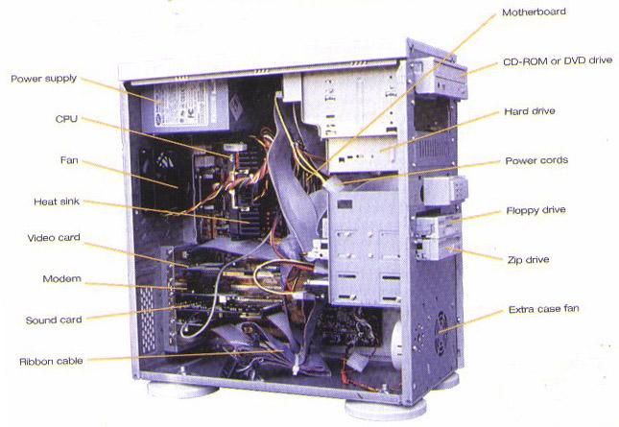
The main components of system unit are here under:
- Mother Board
- CPU
- Primary Memory
- Ports & connectors
- Expansion slots & Adaptor Cards
- Buses
- Power supply

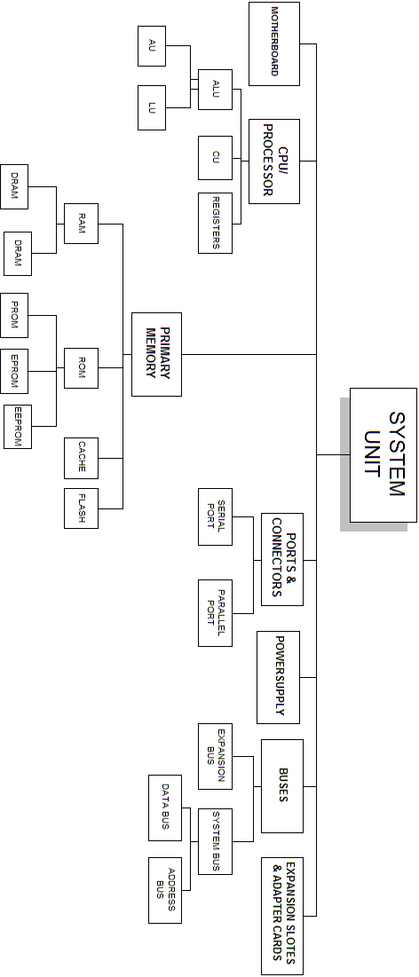

4.1) MOTHER BOARD
The main board of a computer, usually containing the circuitry for the central processing unit, keyboard, and monitor and often having slots for accepting additional circuitry. Also called the "system board," "main board" "base board" or "logic board,"
it is the primary printed circuit board in a computer or other electronic device. In a modern desktop computer, the motherboard contains the CPU, chipset, sockets for memory, as well as all the controller circuits for the disks, keyboard, mouse, network, sound and USB. It may also have a PCI-Express slot for a high-end display adapter and PCI slots for additional peripherals. Laptop motherboards typically have all the peripheral controllers built in.
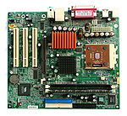
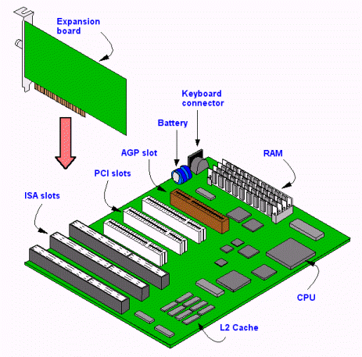

Shortly we can define it as
- Main circuit board in system unit
- Contains chips, integrated circuits, and transistors
- Also called system board

4.2) CENTRAL PROCESSING UNIT
The CPU stands for Central Processing Unit, is the part of a computer system that is commonly referred to as the "brains" of a computer. The CPU is also known as the “processor” or “microprocessor”.
The CPU is responsible for executing a sequence of stored instructions called a program. The programs tells a computer what to do and how to do? This program will take inputs from an input device, process the input in some way and output the results to an output device.

PROCESS
INPUT
OUTPUT

CPU/Processor

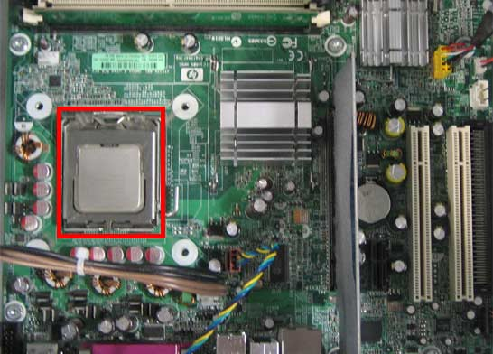

CPUs aren’t only found in desktop or laptop computers, many electronic devices now rely on them for their operation. Mobile phones, DVD players and washing machines are examples of equipment that have a CPU.CPU is located in motherboard. The speed of processing of CPU is about 500 MHz to 2.5 GHz.

PARTS OF CPU
CPU is subdivided in to three parts defined below:
- ALU
- CU
- Register
Arithmetic & Logical Unit
CPU
ALU
CU

Control Unit

- ARITHMETIC & LOGICAL UNIT
ALU stands for “Arithmetic and Logical unit”. This unit of the CPU is capable of performing arithmetic and logical operations. This unit of the CPU gets data from the computer memory and perform arithmetic and logical operations on it.

ALU is further divided in to two parts, Arithmetic unit & Logical unit.
ARITHMETIC UNIT:
The arithmetic unit of ALU performs arithmetic operations like addition, multiplication, subtraction and division.
LOGICAL UNIT:
The Logical unit of ALU performs logical operations such as comparison of two numbers. It tells us which number is greater and which is smaller. The common comparisons such as less than, equal to, or greater than are performed by the logical unit.
REGISTERS:
A processor has its own memory inside it in the shape of small cells. Each memory cell is called a "Register". Registers are used to carry data temporarily for performing operations. There are total 13 registers in a processor. ALU gets data from registers and stores it in registers to perform arithmetic and logical operations. And data comes in registers from main memory of the computer.
- CONTROL UNIT
This unit of the processor controls all the activities of the processor and also controls the input and output devices of the computer. It acts just like a police inspector who controls the traffic on a road.
The control unit controls the whole traffic of the computer. It tells the input device that it is now his turn to feed data in the computer and show result of data after execution on the output units. This unit also controls the flow of instructions, which are given to a computer.
It obtains instructions from the program stored in main memory, interprets (translation of instructions into computer language) the instructions, and issues signals that cause other units of the computer to execute them

WORKING COLLECTING
ALU
CU
Registers
INPUT
OUTPUT

4.3) PRIMARY MEMORY
The primary memory or the main memory is part of the main computer system. The processor or the CPU directly stores and retrieves information from it. This memory is accessed by CPU, in random fashion. That means any location of this memory can be accessed by the CPU to either read information from it, or to store information in it.
There are two types of memory CPU
- RAM
- ROM

- RANDOM ACCESS MEMORY (RAM)
RAM is used to store programs and data that are being used by the computer. When the computer is turned on the RAM is empty. Data and programs can be put into RAM from either an input device or backing store.
The data in RAM is lost when the computer is turned off so it is known as Volatile Memory. To keep data the user must save it to backing store before the computer is turned off.
RAM is further divided in to two types
- DRAM (Dynamic Random access Memory)
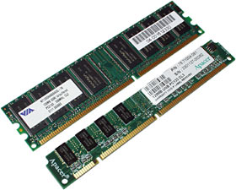
- SRAM (Static Random access Memory)

DRAM
DRAM stands for Dynamic RAM. A type of physical memory used in most personal computers. The term dynamic indicates that the memory must be constantly refreshed (reenergized) or it will lose its contents. RAM is sometimes referred to as DRAM (pronounced dee-ram) to distinguish it from static RAM (SRAM). Static RAM is faster and less volatile than dynamic RAM, but it requires more power and is more expensive.
SRAM
SRAM stands for Static RAM. Short for static random access memory, and pronounced ess-ram. SRAM is a type of memory that is faster and more reliable than the more common DRAM (dynamic RAM). The term static is derived from the fact that it doesn't need to be refreshed like dynamic RAM
- READ ONLY MEMORY (ROM)

The contents of ROM are permanent. It cannot be altered by the user. The content is written onto the ROM when it is first made. ROM keeps its contents even when the computer is turned off and so is known as Non-Volatile Memory.

On some computers a special piece of software called the operating system is stored in ROM. ROM is also often used in embedded systems where a small built-in computer is used to control a device such as a washing machine. The program that controls the machine is stored on ROM.
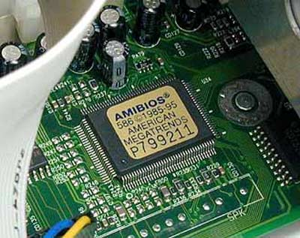

TYPES OF ROM
ROM is further divided in to three types
- PROM (Programmable Read-Only Memory)
- EPROM (Erasable Programmable Read-Only Memory)
- EEPROM (Electronically Erasable Programmable Read-Only Memory)
PROM
PROMs are manufactured as blank chips on which data can be written with a special device called a PROM programmer.
EPROM
A rewritable memory chip that holds its content without power. EPROM chips are written on an external programming device before being placed on the mother board.
EEPROM
A rewritable memory chip that holds its content without power. EEPROMs are typically used on circuit boards to store small amounts of instructions and data.

4.4) PORTS & CONNECTORS
A personal computer may have several ports for connecting devices such as a trackball, expanded keyboard, flatbed scanner, touch screen, and other device peripherals.
It is wise to check what type of port an adaptive device requires to interface with the personal computer. Some computers have many ports, and others may only have a select few of the ports below.
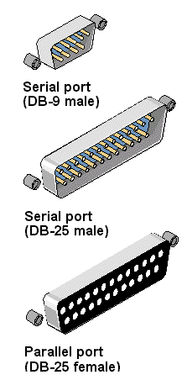

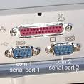

TYPES OF PORTS:
There are two types of ports
- Serial port
- Parallel port
SERIAL PORT:
Serial ports can transfer one bit at a time. A serial communication physical interface through which information transfers in or out one bit at a time.
Throughout most of the history of personal computers, data transfer through serial ports connected the computer to devices such as terminals and various peripherals.
This type of transmission medium is slow as it transmit one bit at a time. It can connect main peripherals of system unit. Like mouse, keyboard etc.
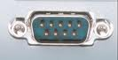
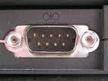

(Serial port connector and port)
PARALLEL PORT:
Parallel port can transfer more that one bit a time. A parallel port is a type of interface found on computers for connecting various peripherals.
In computing, a parallel port is a parallel communication physical interface. It is also known as a printer port or Centronics port.
The IEEE 1284 standard defines the bi-directional version of the port, which allows the transmission and reception of data bits at the same time. It is faster then parallel port as it transfer more than one bit simultaneously
(Note: Bit will be describe in next chapters)
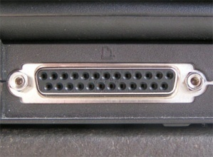

4.5) EXPANSTION SLOTES & ADAPTOR CARDS

Expansion slot is an opening, or socket, where circuit board is inserted into motherboard. Expansion card inserted in expansion slot. Plug and Play was a much-touted feature of the Windows 95 and Windows 98 operating systems.
A PC Card slot, usually located on the side of a notebook computer, allows a PC Card to be changed without having to open the system unit. There are three types of PC Cards:
- Type I cards add memory capabilities to the computer
- Type II cards contain communications devices
- Type III cards house devices such as hard disks
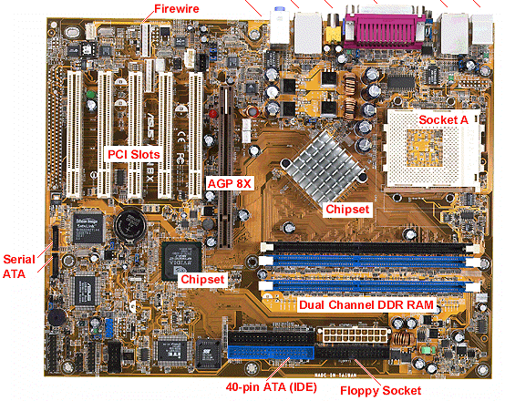
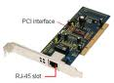
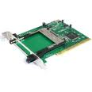

4.6) BUSES
A highway analogy can help clarify how bus width affects the speed of data transfer. Data moves like cars – the more lanes (greater the bus width) the faster the traffic (data) flow. Ideally, buses used to transfer data should be large enough to use the processing power of registers. Sometimes, however, manufacturers reduce bus size to cut costs.
Word size, which indicates the number of bits processed in each machine cycle, has been compared to the amount of coffee produced with each turn of a coffee grinder’s handle. Theoretically, if word size doubles then processor throughput also could double.
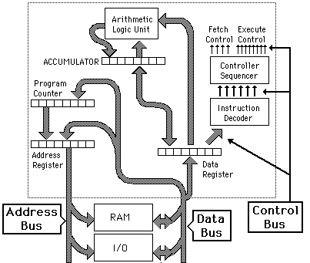

TYPES OF BUSES
- System bus
- Expansion bus

SYSTEM BUS
System bus connects processor and RAM. It is also called internal bus. it is subdivided in to two types:
- Address bus
- Data bus
ADDRESS BUS
The address bus is a unidirectional pathway that carries addresses generated by the microprocessor to the memory and I/O elements of the computer. The size of the address bus, determined by the number of conductors in the bus, determines the number of memory locations and/or I/O elements the microprocessor can address.
DATA BUS
In contrast to the address bus, the data bus is bi-directional in nature. Data flows along the data bus from the microprocessor to memory during a Write operation. Conversely, data moves from memory to the microprocessor during a Read operation. The direction for data movement is the same for Read and Write operations between the microprocessor and Input/Output devices.

EXPANSION BUS
The expansion bus (sometimes called the input/output bus) allows various motherboard components (USB, serial, and parallel ports, cards inserted in PCI connectors, hard drives, CD-ROM and CD-RW drives, etc. to communicate with one another. However, it is mainly used to add new devices using what are called expansion slots connected to the input/output bus.

4.7) POWER SUPPLY

It supply electric supply to all components of system unit. It Converts alternating current (AC) to direct current (DC). It is responsible for supply of power to all components according to its voltage. Min voltage which power supplied is 3V and convert to 24 V. Some peripheral devices have AC adapterlike printers and scanners.

